#Segment 5: Crew Analysis

#Identify the columns in the names table that have null values.

#Determine the top three directors in the top three genres with movies having an average rating > 8.

#Find the top two actors whose movies have a median rating >= 8.

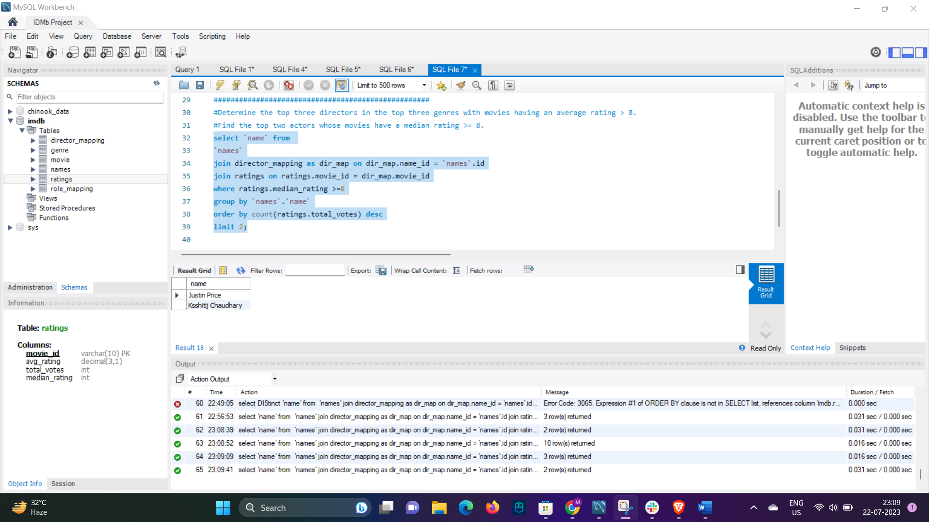

#Identify the top three production houses based on the number of votes received by their movies.

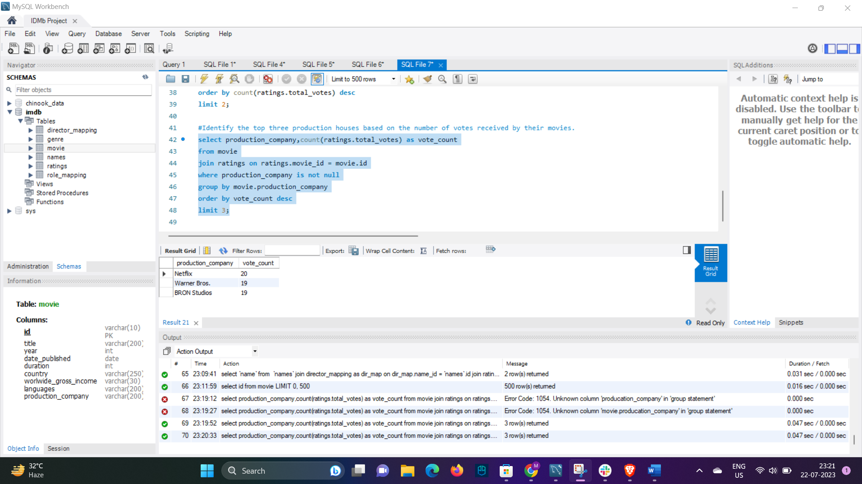

#Rank actors based on their average ratings in Indian movies released in India.

#Identify the top five actresses in Hindi movies released in India based on their average ratings.

